|  |
| --- |
| Capstone |
| MERRIMACK COLLEGE |

Touch-Screen Smart Mirror

Concept Assessment

EEN4960A

Design Project I

Kyle Skey

September 12, 2016

# Market Assessment

## Introduction

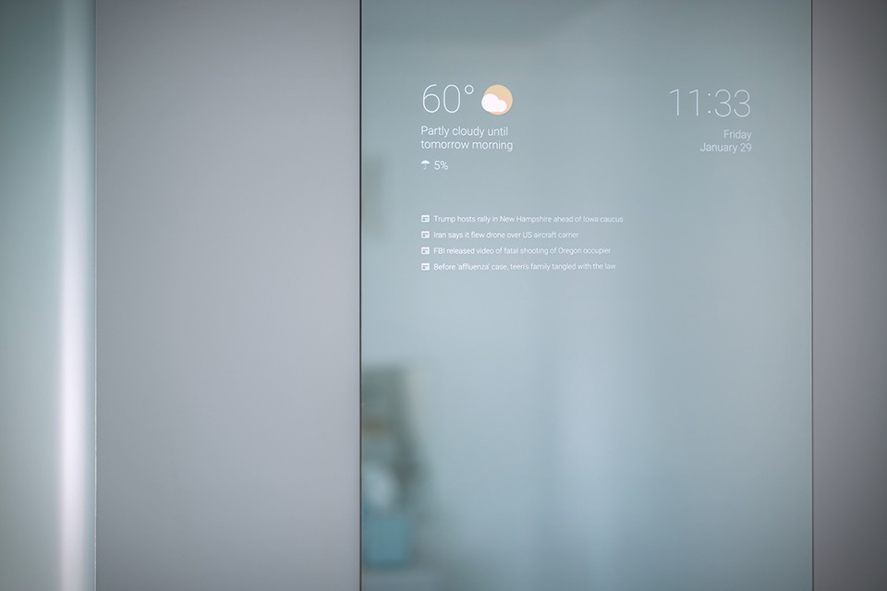In recent years, the Internet of Things (IoT) market has been expanding, as Wi-Fi speeds increase and embedded processing modules decrease in size and become more affordable. One such product that has immerged from this technology trend is the smart mirror (Figure 1). The most basic of smart mirrors involves placing a 2-way acrylic mirror on top of a computer or TV display. While keeping the background black, any light colored text will emit though the mirror glass and be seen on the user side. While this implementation is novel at best, it lacks customization and usability from someone who knows little or no programming.

Figure 1: Example Basic Smart Mirror

The biggest problem with the hobbyist smart mirror is it has no user interface. There is no way for the user to interact with their smart mirror. To remedy this, a touch screen interface can be constructed into the frame of the mirror. With the accompaniment of software and application development, users of the smart mirror could be able to type text, load marketplace applications (Android, Apple, etc.), and customize their smart mirror to display information relevant to them. This could possibly make smart mirrors as desirable as an iPad or other tablet.

## Specifications

* Resizable range (active area): TBD
* Maximum resolution = 4096 x 4096
* Response time: 50-60 rps (response per second).
* Operating temperature: 0 to 70 degree C.
* Interface: USB 1.1 or higher.
* Power: 5VDC, 500 mA (power supply included).
* Operating system: Windows 7, 8,10 & Linux
* Driver: Linux/Windows mouse emulation.

# Technical Assessment

## Touch Screen Overview

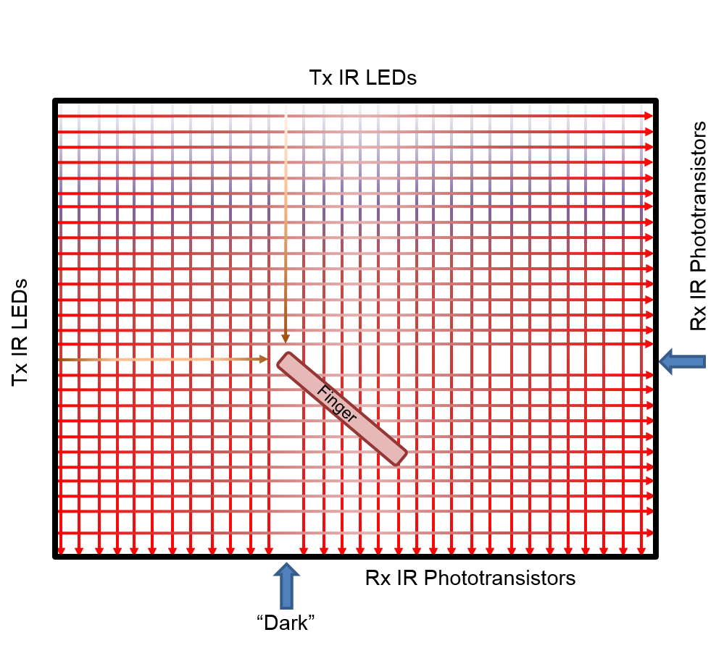There are two mainstream techniques for touch screen construction, capacitive and infrared (IR). While the capacitive touch screen is more desirable in terms of form-factor, its implementation on such a large of scale is difficult and expensive. Therefore, the touch screen will be developed using a grid of IR transmitters and receivers. IR LED transmitters will be placed in one horizontal and vertical axis of the display, side by side. IR Phototransistor receivers will be placed opposite of the transmitters, one for each transmitter. This will create a grid of IR light in the horizontal and vertical axis of the display (Figure 2). When an object (preferably a finger) enters the grid, it will block the IR light from the receiver in the horizontal and vertical axis, resulting in a calculated coordinate of that object. This coordinate can then be sent to a computer as a “click” of a mouse at a certain location.

Figure 2: IR Grid Diagram

## IR Tx/Rx Circuits

In theory, it is a simple task to use one IR LED to illuminate one IR Phototransistor and turn that into a binary signal which gets read by a microprocessor. The challenge is having over 200 transmitter-receiver pairs properly aligned and all reading into the same processor. This large scale implementation presents many challenges in the design and fabrication process, which include, but are not limited, to the following:

* Power consumption – Each LED uses approx. 100mA per unit. 200 x 100mA x 5V = 100W!!!
* Interference – When trying to read a receiver, adjacent LEDs could provide illumination that set off a false negative
* I/O lines – Microprocessors do not have 200+ I/O lines and using multiple microprocessors is too expensive and tricky
* PCB Construction – In order to have a small form-factor, PCBs will be used to mount the LED Tx/Rx circuits. It will be costly to make a 30” PCB, especially if there are errors in the first iteration

Many of these challenges can be solved by only illuminating one LED at a time and taking a reading only on its paired receiver. This will take care of the power consumption and interference problems as only one light will be on at a time. To solve the I/O line problem the Tx/Rx units will have to be grouped in units of 8, using transistors, and serialized in some way. These basic groups can be placed in larger groups of 3 or 4 and placed on a PCB. The PCBs will have to be designed in such a way that they are also serialized in their communication with the controller. This can be achieved numerous ways, but initial analysis shows the following chips to be the best course of action:

* 74HCT138 - 3-to-8 line decoder/demultiplexer – This will be used to toggle the Tx LEDs, one at a time, within the larger group of 8.
* 74HCT164 - 8-bit serial-in, parallel-out shift register – This will be used to toggle each group of 8. These chips will be daisy-chained from PCB to PCB so that the last valid high in the parallel-out will trigger a high in the serial-in for the next chip.

With a clever clocking and I/O scheme, it should be possible to modularize both Tx and Rx boards.

## Tx/Rx Sensitivity

Testing of the QED123 IR LED Transmitter and the QSD123 IR Phototransistor Receiver shows an approximate 1V drop across a 1k-ohm collector resistor (emitter tied to ground) on the receiver when placed 30” away from the transmitter with ambient light and using a 5V supply. Blockage of the transmitter from the receiver shows a 0V drop across the same collector resistor. This voltage drop increases as the distance between the two devices decreases. Since the max distance for this particular project is 30”, the two devices are sufficient to determine “light” vs. “dark”. An initial calibration of these values will need to occur at the time of startup to determine the ADC reading for each receiver at its given ambient light. This value can be used to determine partial blockage of a receiver to increase the resolution.

## Block Diagrams

### High Level

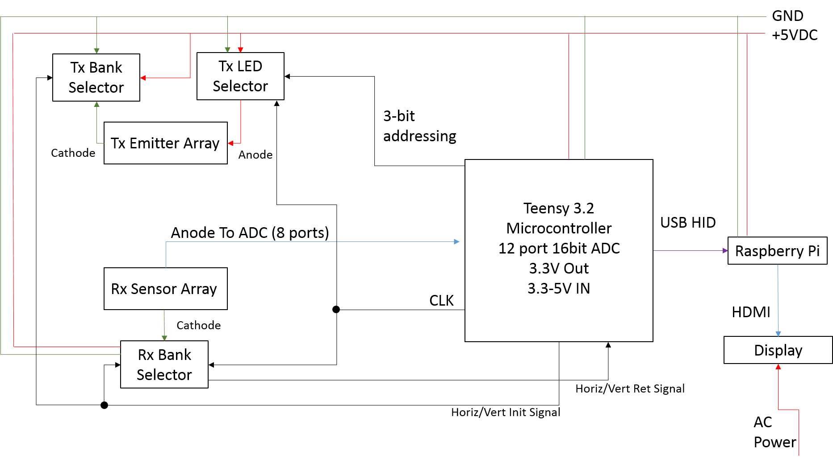

### Low Level Rx/Tx Config

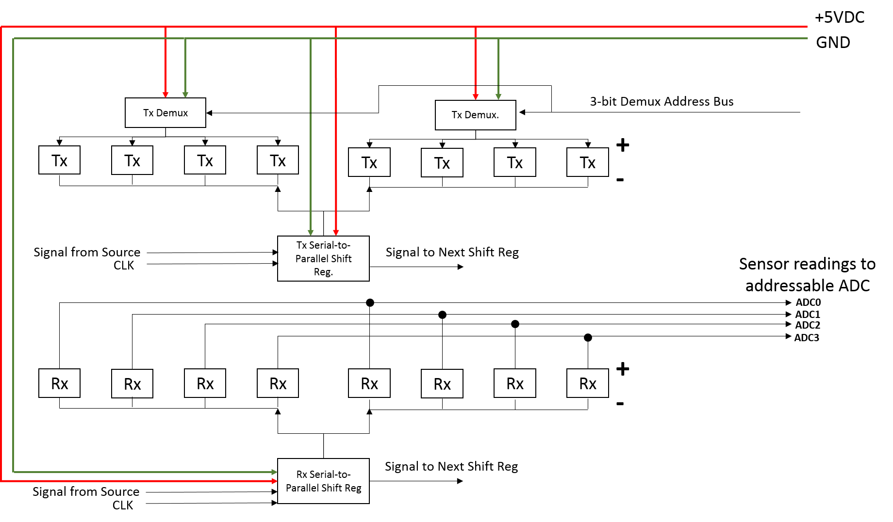

## Schematics

### Tx IR Array (Includes Extra Signals for Simulation not in Final Design)

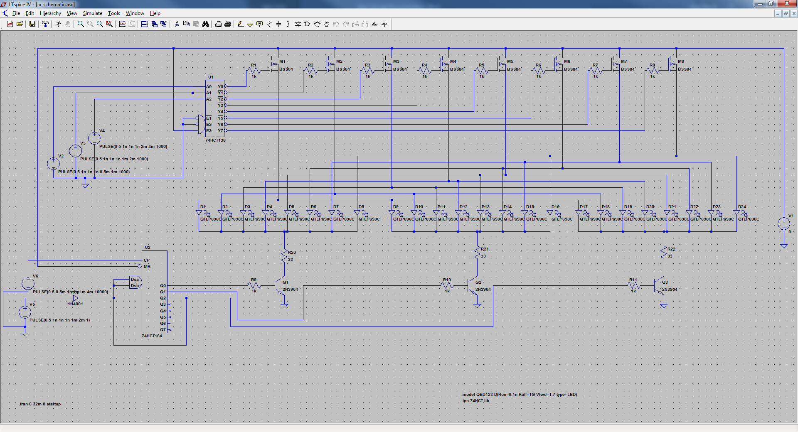

# Financial Assessment

From preliminary analysis, the following parts and services will be needed to complete this project. A microprocessor will be chosen once IR grid circuit and clocking scheme is determined. Some prices have been estimated.

|  |  |  |  |  |  |  |
| --- | --- | --- | --- | --- | --- | --- |
| Name | Vendor | Part Number | Cost/Unit | Units | Total | Description |
| IR Tx LED | Digi-Key | Top of Form  QED123-ND  Bottom of Form | $0.26 | 250 | $66.06 | Top of Form  EMITTER IR 880NM 100MA RADIAL  Bottom of Form |
| IR Rx Detector | Digi-Key | QSD123A4R0CT-ND | $0.33 | 250 | $82.50 | Top of Form  PHOTOTRANSISTOR DETECTOR 5MM  Bottom of Form |
| 74HCT138 | Digi-Key | 296-1608-5-ND | $0.50 | 10 | $5.00 | IC 3-8 LINE DECODER/DEMUX 16-DIP |
| 74HCT164 | Digi-Key | 296-2097-5-ND | $0.56 | 20 | $11.20 | IC 8-BIT SHIFT REGISTER HS 14DIP |
| NPN Transistor | Digi-Key | 2N3904 | $0.06 | 40 | $2.40 | TRANS NPN 40V 0.2A TO-92 |
| Resistors | Unk | Unk | $10.00 | 1 | $10.00 | Biasing Resistors |
| Connectors | Unk | Unk | $20.00 | 1 | $20.00 | Board-Board Connectors |
| 32" LED TV | Bestbuy.com | NS-32D310NA17 | $100 | 1 | $100.00 | Insignia8482 32 Class 315 Diag LED 720p HDTV Black |
| 2-Way Acrylic Glass | Unk | Unk | $50.00 | 1 | $50.00 | Mirror glass for display |
| Microprocessor | Adafruit | Teensy 3.2 | $19.95 | 1 | $20.00 | Processor unit with built-in 16-bit ADC and USB HID capability |
| RaspberryPi 3 | Unk | Unk | $30.00 | 1 | $30.00 | Computer to display Smart Mirror apps |
| PCB |  |  | $150 | 1 | $150.00 |  |
|  |  |  |  |  |  |  |
|  |  |  |  | Total | $508.70 |  |